Ignasi Arranz, Bertrand Fournier, Nigel P. Lester, Brian J. Shuter, and Pedro R. Peres-Neto. Species compositions mediate biomass conservation: the case of lake fish communities. Ecology.

Appendix S4. Contribution of the PCoA axes for the biomass and presence-absence data

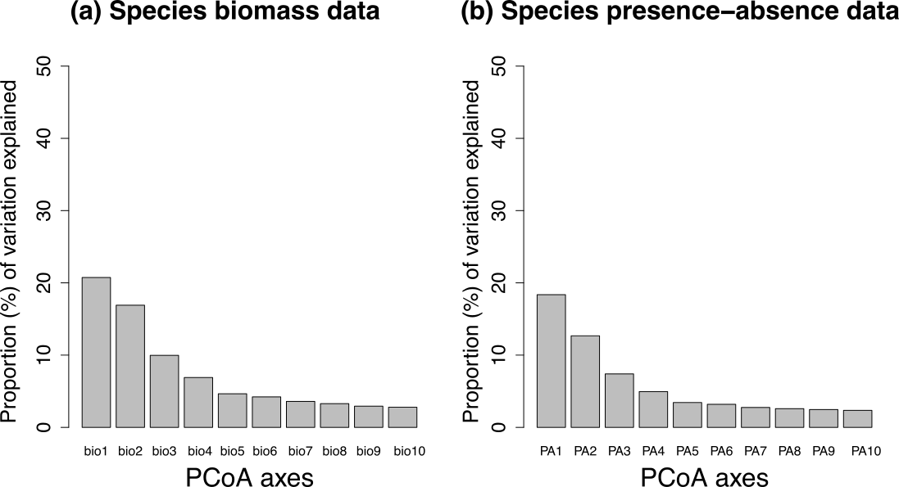

**Figure S1.** Bar plots showing the proportion of variation explained for the first 10 PCoA axes in species biomass data (a) and species presence-absence data.